**Data Modeling:**

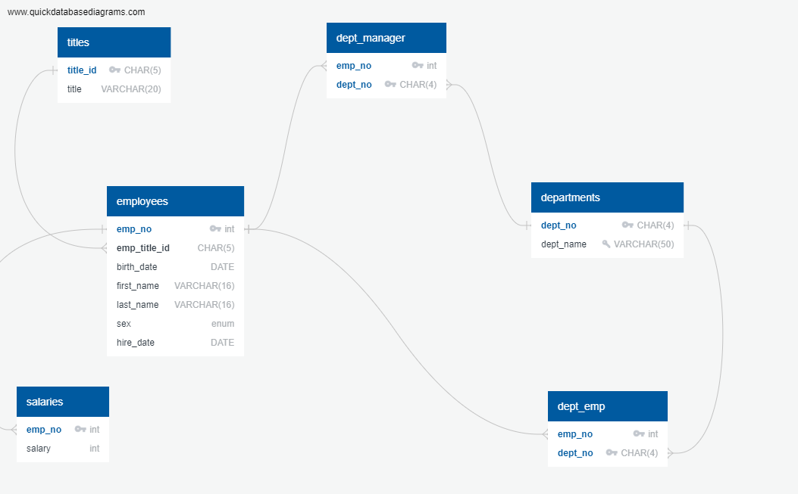

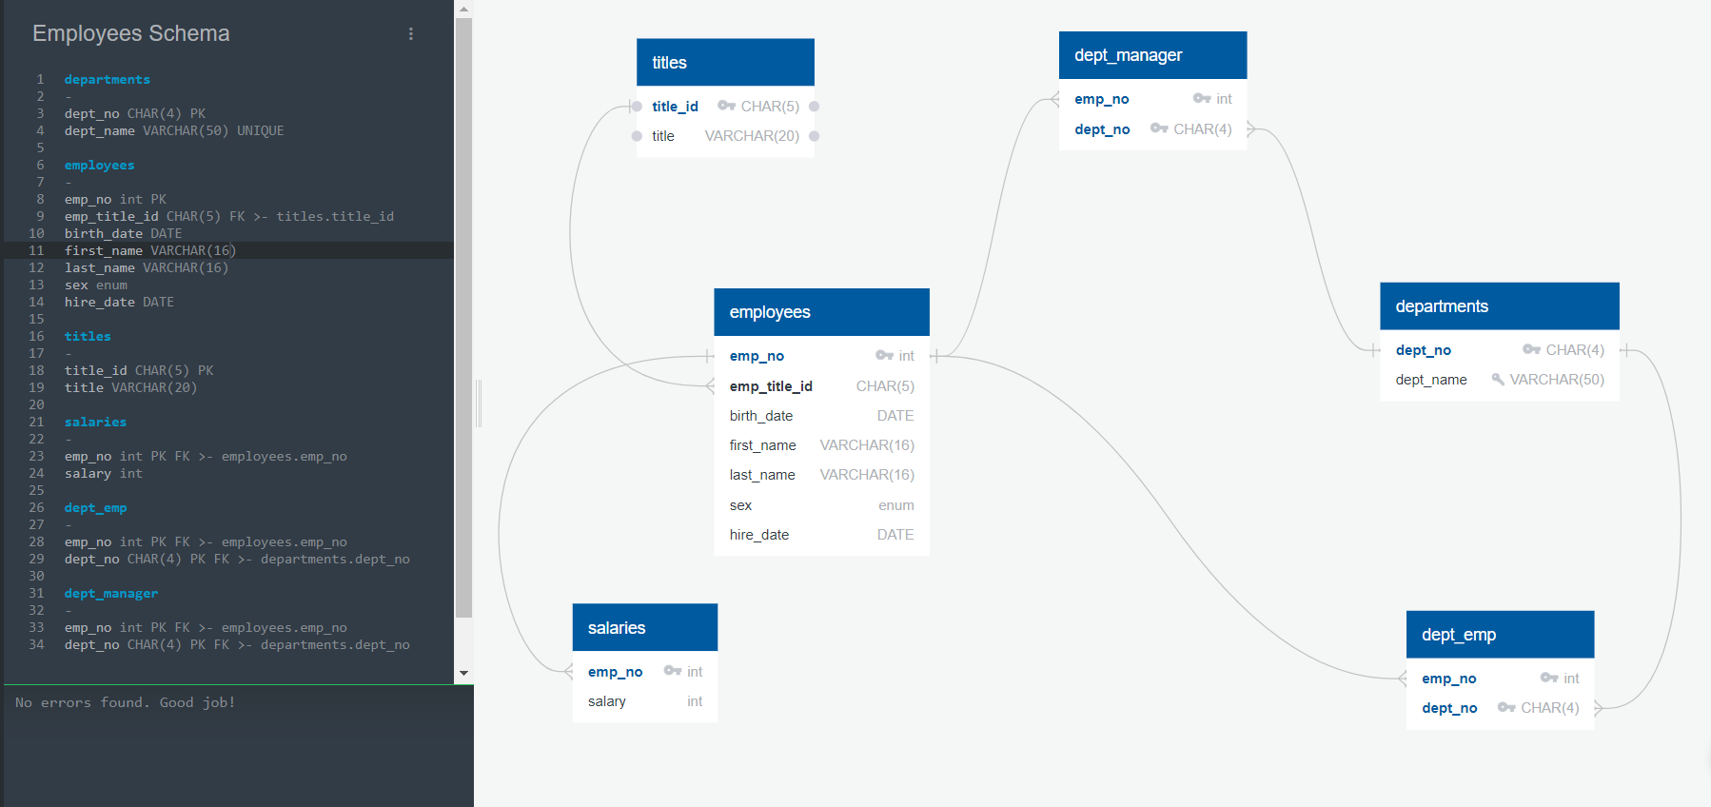

**Data Engineering:**



|  |
| --- |
| CREATE DATABASE employee_data;  USE employee_data;  CREATE TABLE departments(  dept_no CHAR(4) PRIMARY KEY NOT NULL,  dept_name VARCHAR(50) UNIQUE NOT NULL  );  CREATE TABLE titles (  title_id CHAR(5) PRIMARY KEY NOT NULL,  title VARCHAR(20)  );  CREATE TABLE employees (  emp_no INT PRIMARY KEY NOT NULL,  emp_title_id CHAR(5) NOT NULL,  birth_date DATE,  first_name VARCHAR(16),  last_name VARCHAR(16),  sex CHAR(1)  hire_date DATE,  FOREIGN KEY (emp_title_id) REFERENCES titles(title_id));  CREATE TABLE salaries (  emp_no INT NOT NULL,  salary INT,  PRIMARY KEY (emp_no),  FOREIGN KEY (emp_no) REFERENCES employees(emp_no) );  CREATE TABLE dept_emp (  emp_no INT NOT NULL,  dept_no CHAR(4) NOT NULL,  PRIMARY KEY (emp_no, dept_no),  FOREIGN KEY (emp_no) REFERENCES employees(emp_no),  FOREIGN KEY (dept_no) REFERENCES departments(dept_no) );  CREATE TABLE dept_manager (  emp_no INT NOT NULL,  dept_no CHAR(4) NOT NULL,  PRIMARY KEY (emp_no, dept_no),  FOREIGN KEY (emp_no) REFERENCES employees(emp_no),  FOREIGN KEY (dept_no) REFERENCES departments(dept_no) ); |

**Data Analysis:**

* List the employee number, last name, first name, sex, and salary of each employee

| SELECT e.emp_no, e.last_name, e.first_name, e.sex, s.salary FROM employees e JOIN salaries s ON e.emp_no = s.emp_no; |
| --- |

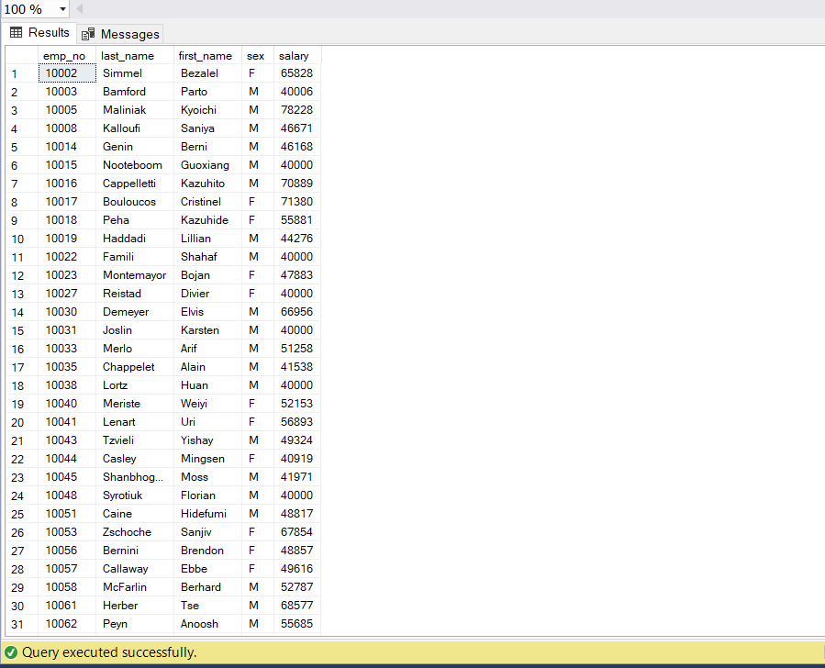

* List the first name, last name, and hire date for the employees who were hired in 1986

| SELECT first_name, last_name, hire_date FROM employees WHERE YEAR(hire_date) = 1986; |
| --- |

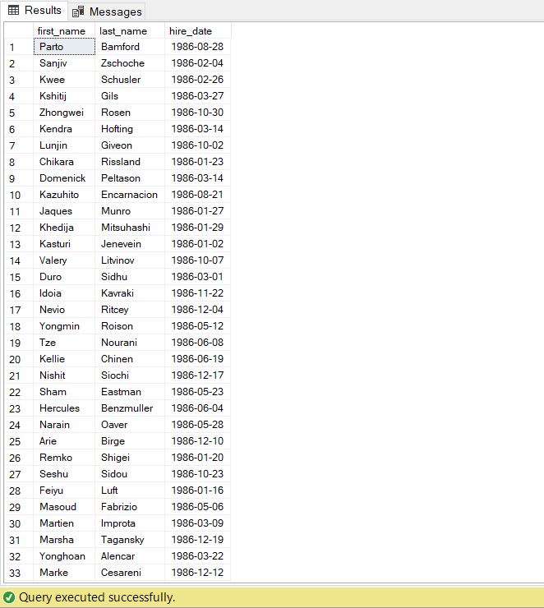

* List the manager of each department along with their department number, department name, employee number, last name, and first name

| SELECT dptm.dept_no, d.dept_name, dptm.emp_no, e.last_name, e.first_name FROM dept_manager dptm JOIN departments d  ON dptm.dept_no = d.dept_no JOIN employees e  ON dptm.emp_no = e.emp_no; |
| --- |

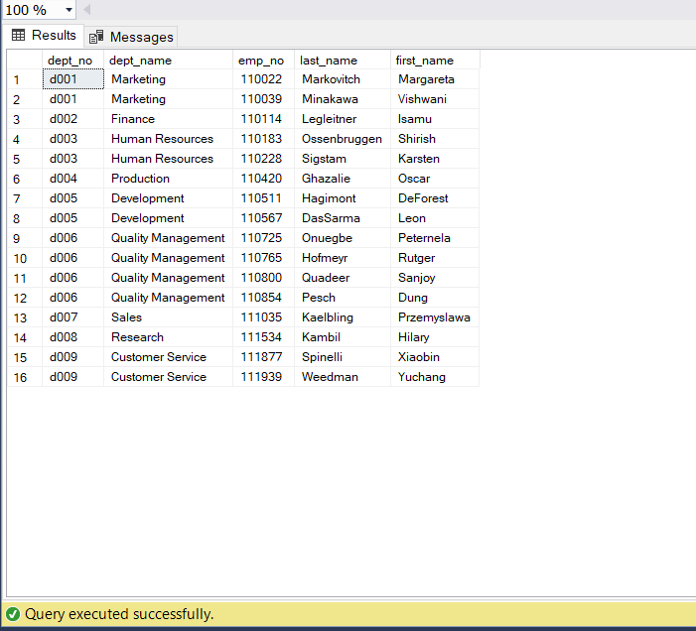

* List the department number for each employee along with that employee's employee number, last name, first name, and department name

| SELECT dept.dept_no, dept.emp_no, e.last_name, e.first_name,d.dept_name FROM dept_emp dept JOIN departments d  ON dept.dept_no = d.dept_no JOIN employees e  ON dept.emp_no = e.emp_no; |
| --- |

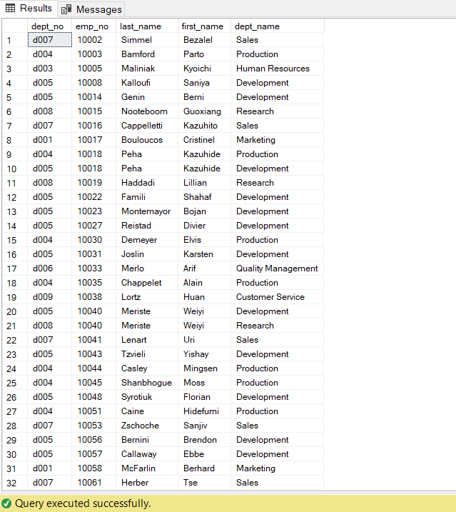

* List first name, last name, and sex of each employee whose first name is Hercules and whose last name begins with the letter B

| SELECT first_name, last_name, sex FROM employees WHERE first_name = 'Hercules'  AND last_name LIKE 'B%'; |
| --- |

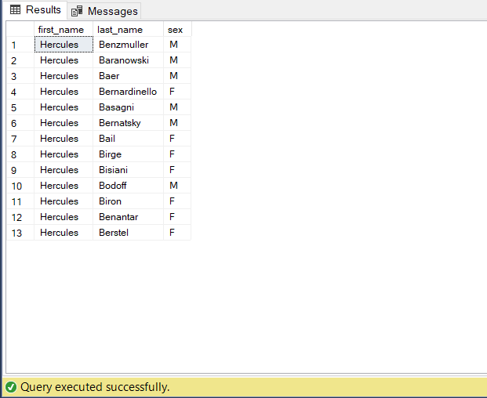

* List each employee in the Sales department, including their employee number, last name, and first name

| SELECT e.emp_no, e.last_name, e.first_name FROM employees e JOIN dept_emp de ON e.emp_no = de.emp_no JOIN departments d ON de.dept_no = d.dept_no WHERE d.dept_name = 'Sales'; |
| --- |

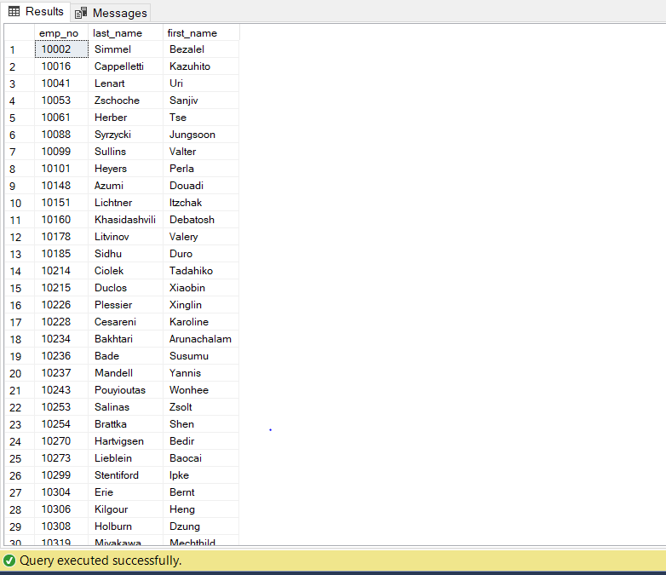

* List each employee in the Sales and Development departments, including their employee number, last name, first name, and department name

| SELECT e.emp_no, e.last_name, e.first_name, d.dept_name FROM employees e JOIN dept_emp de  ON e.emp_no = de.emp_no JOIN departments d  ON de.dept_no = d.dept_no WHERE d.dept_name IN ('Sales', 'Development'); |
| --- |

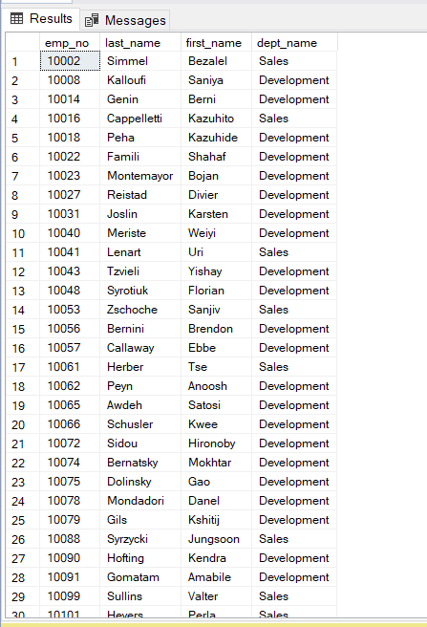

* List the frequency counts, in descending order, of all the employee last names (that is, how many employees share each last name)

| SELECT last_name, COUNT(*) AS frequency FROM employees GROUP BY last_name ORDER BY frequency DESC; |
| --- |

